28.84: The amount of charge on a length  of the belt is:

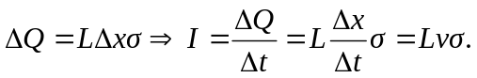
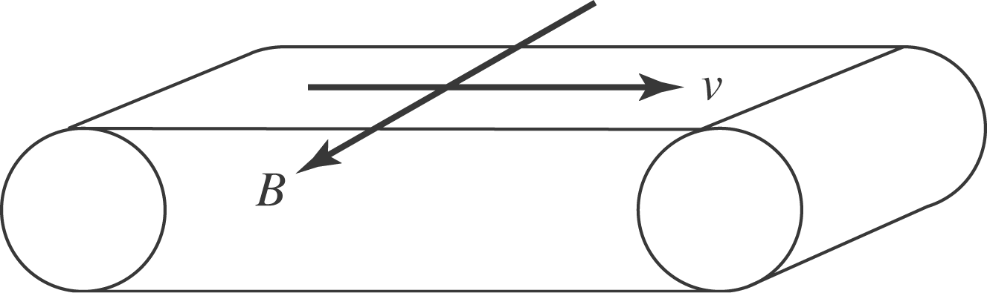

Approximating the belt as an infinite sheet:
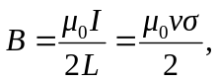
out of the page, as shown at left.

